MalakSoni_DA_Intern_Day08
Day 8: Data Engineering and ETL Processes

Morning Session:

Understanding data engineering concepts: ETL (Extract, Transform, Load) processes.

ETL, which is Extract, Transform, Load, is the process where we store data from multiple places, perform some changes, and store it to a new place. This process involves extracting data from various sources, transforming it to fit operational needs, and loading it into a target database or data warehouse.

ETL is good to analyze and make reports from the data. It helps in consolidating data from different sources, ensuring it is clean, accurate, and useful for business intelligence and analytics.

ETL Operations:
Data cleansing: Ensuring the data is accurate and free from errors.
Remove Duplicates: Eliminating duplicate entries to maintain data integrity.
Keys and ID: Creating or ensuring unique identifiers for data entries.
Combine and merge data: Integrating data from different sources to provide a comprehensive dataset.

Hands-on with data wrangling tools: Apache Spark, SQL for data manipulation.

Participants will engage in practical exercises using Apache Spark for large-scale data processing and SQL for querying and manipulating structured data. These tools are essential for efficient data engineering, enabling robust ETL workflows.

An ETL pipelines is the system that allows ETL activities to take place. Data pipelines are a collection of tools and actions used to transfer data from one system with its own manner of data storage and processing to another system where is might be kept and managed differently.
ETL is used to combine structure and unstructured data and to store it in a warehouse , To deal with BIG and Massive amount of Data also Hadoop ETL.
Data Wrangling with Python Hands on:
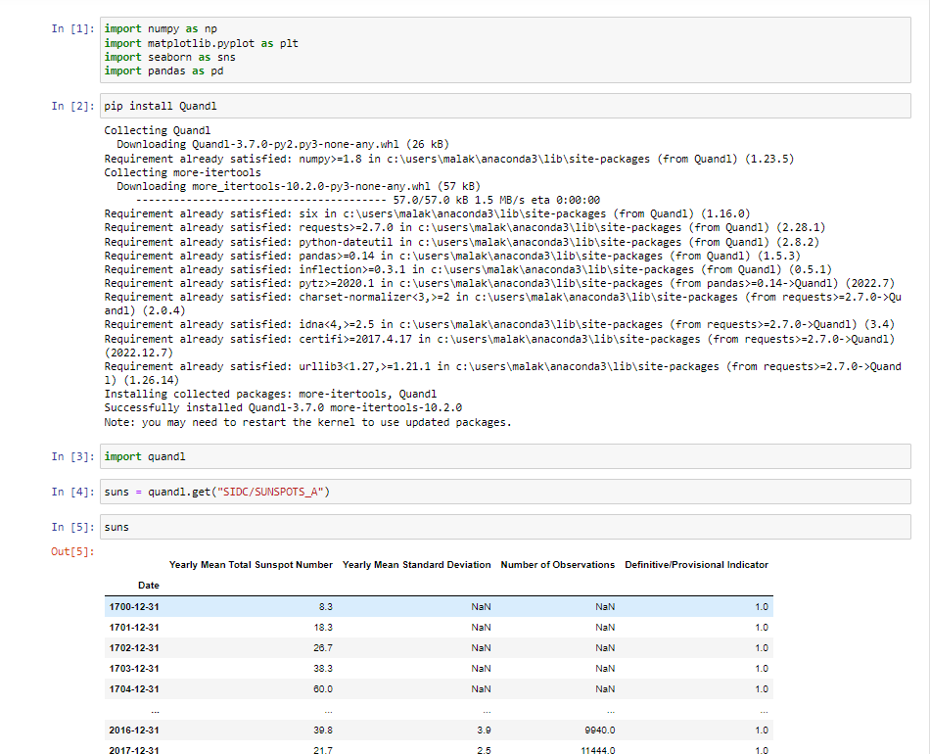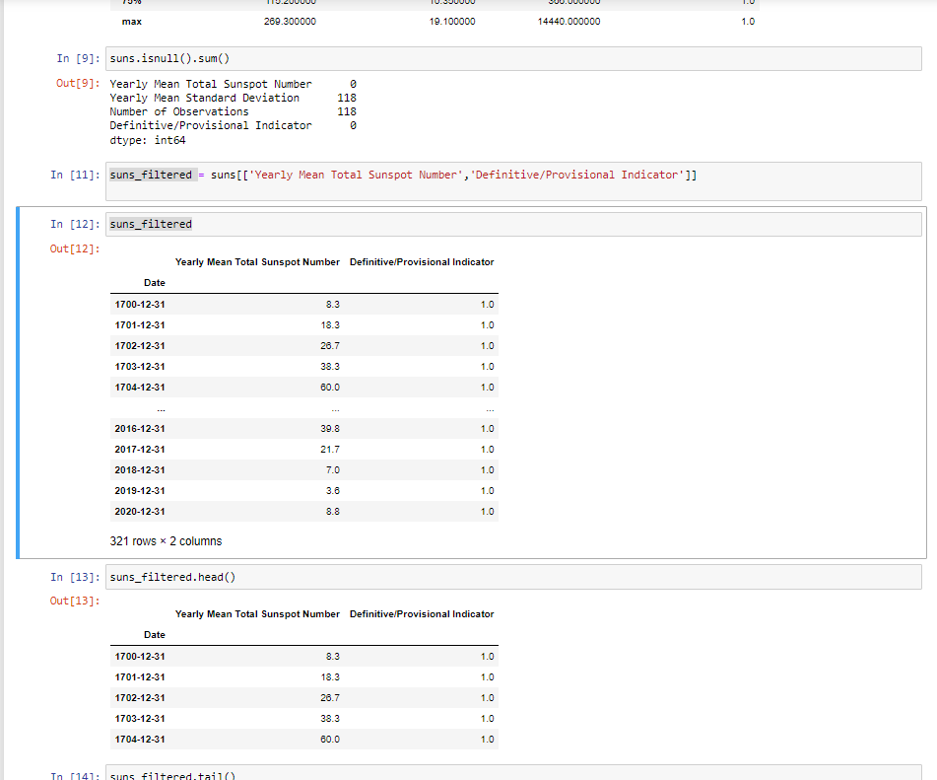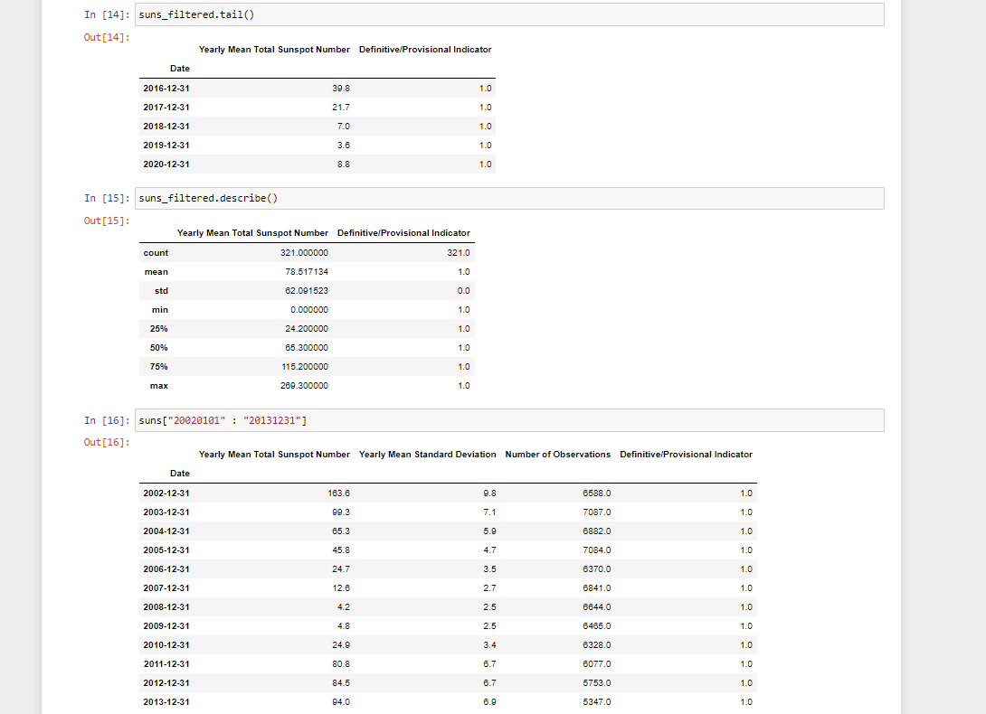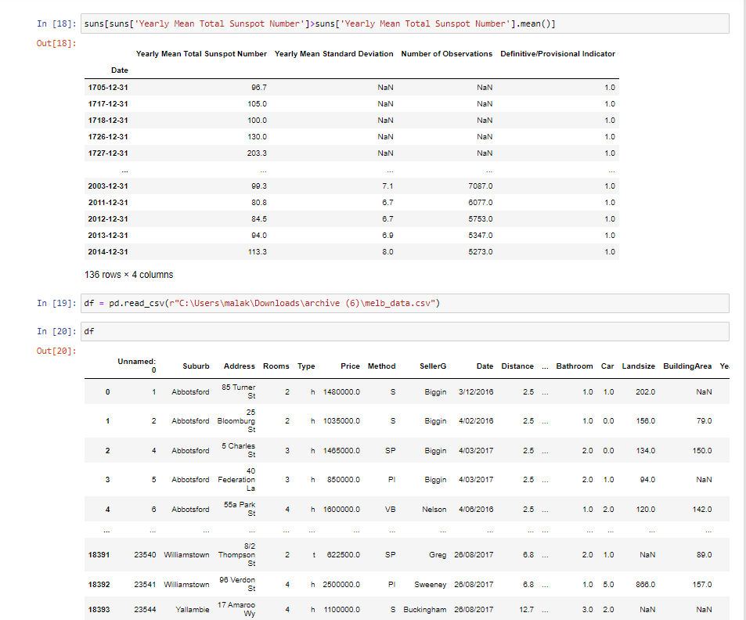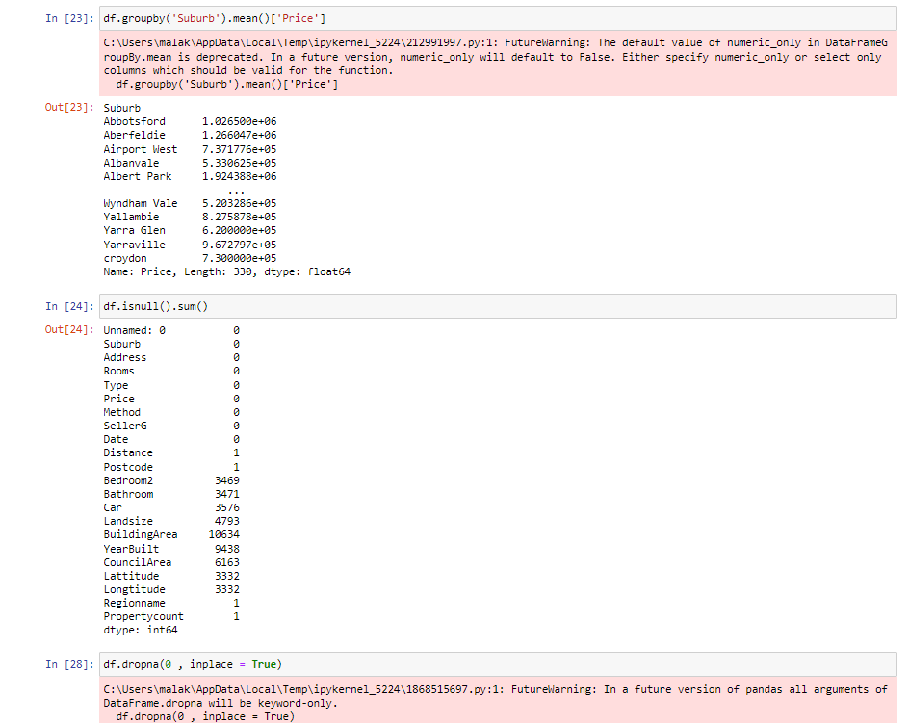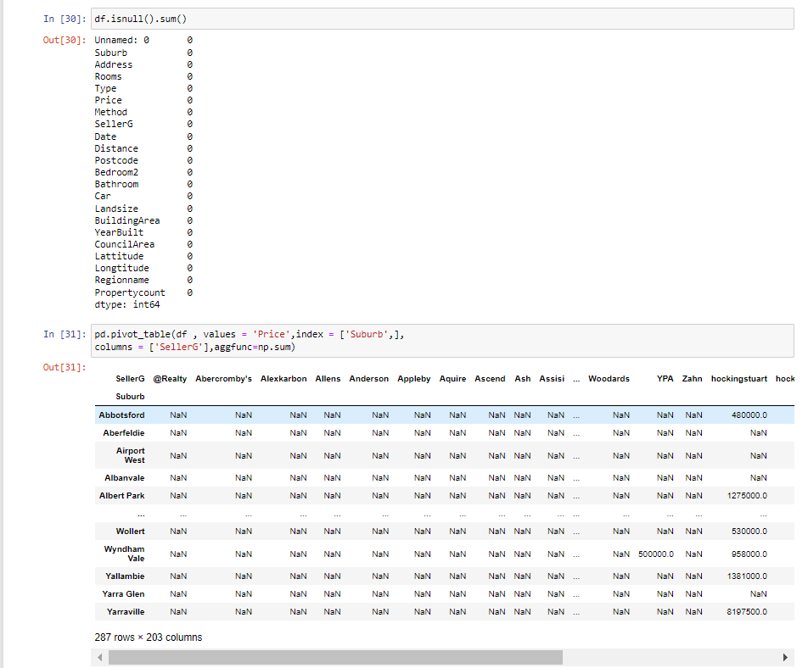

Afternoon Session:
- Practical exercises: Building ETL pipelines and data transformation workflows.
https://youtu.be/dfouoh9QdUw?si=uNecNW4rnamBf2By

End of Day08
****************************Thank You*****************************

